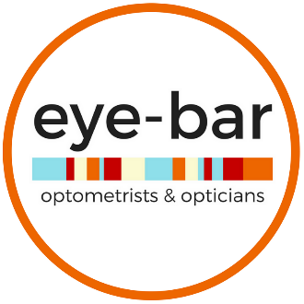

How to Choose the Perfect Pair of Glasses

- Determine your face shape. Look at yourself in the mirror or ask a friend to determine your key features. The most common face shapes are oval, round, square, rectangular or heart-shaped.

- Get hands on with the styles and try everything on. How the glasses look on a picture or on the shelf does not help you when it comes to knowing if it suits you. If you gravitate to a certain shape or colour, ask yourself what it is that appeals to you about that frame and how it makes you look and feel.

- Consider picking more than one pair. You need to feel comfortable with wearing your glasses during your various lifestyle activities. Activities such as golfing, reading, computer work, driving, and sports often require a specialized pair of glasses. Your eyewear specialist can also help you determine if the prescription needs to be adjusted to help suit your activities. Fashion also plays a role - be brave and pick out an exciting pair to wear when you feel adventurous.

- You do you. No matter what your face shape or wardrobe colours are, you need to feel confident knowing that your glasses not only optimize your vision in all circumstances, but that you feel amazing in them.

#loveyoureyewear
Look good. See better. Feel confident.

